Assignment
Vehicle Service and Maintenance Tracker
done by: Abdulla Moulana, Mohammed Albustami
Instructor: Hussam Fetyan

Part 1
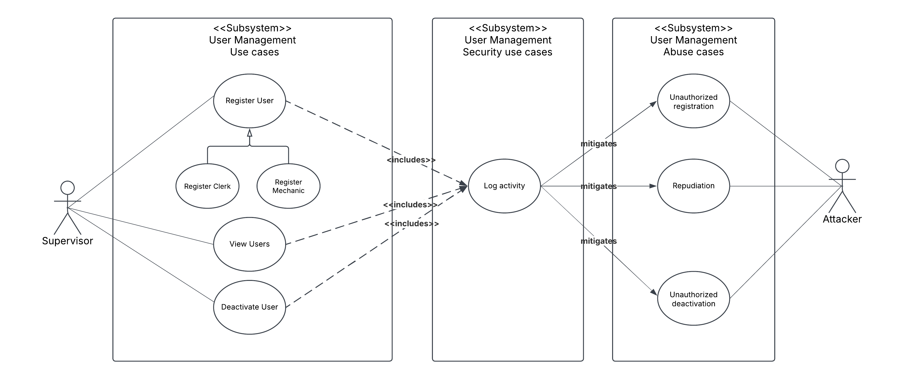
Use case Id: | UM-001
Name: | Register user
Created By/Author: | Abdulla Moulana, Mohammed Albustami
Date Created: | 24/03/2025
Actor: | Supervisor
Description/Summary: | The Supervisor registers a new employee (Clerk or Mechanic) into the system with his name, role etc
Preconditions: | A Supervisor must be logged in to use this feature and must have the necessary permissions associated with his account
Postconditions: | A new user account is created in the database for using the application  An audit log entry is recorded
Normal course of events: | Supervisor selects "Register User" from the User Management Interface, enters user details (name, role etc.) and clicks register
Exceptions: | If the user already exists, an error is displayed  If any required fields are empty or wrong
Acceptance Criteria: | The user is registered and the user can log in

Use case Id: | UM-002
Name: | Deactivate user
Created By/Author: | Abdulla Moulana, Mohammed Albustami
Date Created: | 24/03/2025
Actor: | Supervisor
Description/Summary: | The Supervisor deactivates an employee’s account, denying further access to the system
Preconditions: | A Supervisor must be logged in to use this feature and must have the necessary permissions associated with his account  The user account getting deactivated must exist
Postconditions: | The user account is deactivated and cannot be accessed  An audit log entry is recorded
Normal course of events: | Supervisor selects "Deactivate User" from the User Management Interface, selects user, and clicks deactivate
Exceptions: | If the target user is a Supervisor account  If the user does not exist, an error is displayed
Acceptance Criteria: | The user account is deactivated and the user cant log in

Use case Id: | UM-003
Name: | View Users
Created By/Author: | Abdulla Moulana, Mohammed Albustami
Date Created: | 24/03/2025
Actor: | Supervisor
Description/Summary: | The Supervisor deactivates an employee’s account, denying further access to the system
Preconditions: | A Supervisor must be logged in to use this feature and must have the necessary permissions associated with his account
Postconditions: | User list is displayed with their name and role
Normal course of events: | Supervisor selects "View Users" from the User Management Interface
Exceptions: | If no users exist, display "No users found."
Acceptance Criteria: | Supervisor sees a up-to-date user list.

Use case Id: | SUM-001
Name: | Log activity
Created By/Author: | Abdulla Moulana, Mohammed Albustami
Date Created: | 24/03/2025
Actor: | App/System
Description/Summary: | Ensures all critical user management activities are logged and stored securely for security and compliance purposes and also for repudiation
Preconditions: | A security-related action (Register User or Deactivate User) is performed.  The system logging service must be operational.
Postconditions: | An audit log entry is created with timestamps, user details, and the performed action
Normal course of events: | After the related action is performed, the system records the action, the user and the time and is stored in the database.
Exceptions: | None
Acceptance Criteria: | Successfully logged and stored in the database with al the details

Abuse case Id: | AUM-001
Name: | Unauthorized Registration
Created By/Author: | Abdulla Moulana, Mohammed Albustami
Date: | 24/03/2025
Priority: | High
Scope: | User Management System
Development Environment: | Desktop Application
Mis-actors: | Malicious Supervisor or Account Stolen
Access Right Levels: | High Level System Users and System Admin
Point of Entry: | User Management Interface
Security Attributes Affected: | Confidentiality and Integrity
Description: | An attacker registers fake users in the system, potentially leading to fraud and/or unauthorized access
Sophistication: | Requires access to a Supervisor’s account to access the User Management module
Preconditions: | The account logged in must be a Supervisor account level
Assumptions: | Employee information is not cross-checked with HR records by the system
Postconditions: | An unauthorized user gains access to the system  The fraudulent account could be used for illicit activities.
Related Use Cases: | UM-001  SUM-001
Related Threats: | Insider Threat  Data Manipulation  Identity Theft
Exceptions: | N/A
Acceptance Criteria: | An unauthorized user gains access to the system and can perform tasks that are fradulent

Abuse case Id: | AUM-002
Name: | Unauthorized Deactivation
Created By/Author: | Abdulla Moulana, Mohammed Albustami
Date: | 24/03/2025
Priority: | High
Scope: | User Management System
Development Environment: | Desktop Application
Mis-actors: | Malicious Supervisor or Account Stolen
Access Right Levels: | High Level System Users and System Admin
Point of Entry: | User Management Interface
Security Attributes Affected: | Availability
Description: | An attacker deactivates users in the system, denying further access to the system
Sophistication: | Requires access to a Supervisor’s account to access the User Management module
Preconditions: | The account logged in must be a Supervisor account level
Assumptions: | Intent on denial of Service
Postconditions: | A legitimate user loses access to the system  Denial of Service
Related Use Cases: | UM-002  SUM-001
Related Threats: | Insider Threat  Identity Theft
Exceptions: | N/A
Acceptance Criteria: | An legitimate user loses access to the system and cannot perform work

Abuse case Id: | AUM-003
Name: | Repudiation
Created By/Author: | Abdulla Moulana, Mohammed Albustami
Date: | 24/03/2025
Priority: | Medium
Scope: | User Management System
Development Environment: | Desktop Application
Mis-actors: | Malicious Supervisor or Account Stolen
Access Right Levels: | High Level System Users and System Admin
Point of Entry: | User Management Interface
Security Attributes Affected: | Confidentiality
Description: | An attacker views sensitive user lists but later denies doing so
Sophistication: | Requires access to a Supervisor’s account to access the User Management module
Preconditions: | The account logged in must be a Supervisor account level
Assumptions: | Attacker may act maliciously
Postconditions: | Attacker views sensitive data
Related Use Cases: | UM-003  SUM-001
Related Threats: | Insider Threat  Identity Theft  Data leak
Exceptions: | N/A
Acceptance Criteria: | Attacker successfully views user data without a trace

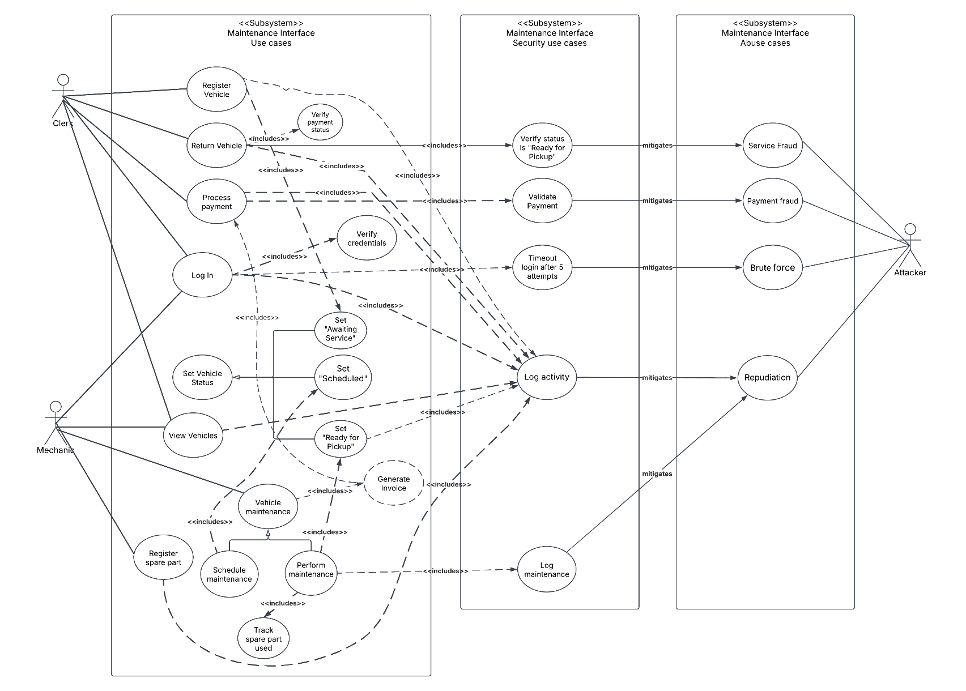
Use case Id: | MI-001
Name: | Register Vehicle
Created By/Author: | Abdulla Moulana, Mohammed Albustami
Date Created: | 24/03/2025
Actor: | Clerk
Description/Summary: | Clerk registers a new vehicle into the maintenance system with details like VIN, make, and model
Preconditions: | Clerk must be logged in
Postconditions: | Vehicle is added to the system  Invoice is generated
Normal course of events: | Clerk selects “Register Vehicle” and enters the vehicle’s details  System validates and saves the record
Exceptions: | Duplicate VIN in the database
Acceptance Criteria: | Vehicle is successfully added to the database

Use case Id: | MI-002
Name: | Return Vehicle
Created By/Author: | Abdulla Moulana, Mohammed Albustami
Date Created: | 24/03/2025
Actor: | Clerk
Description/Summary: | Clerk returns a serviced vehicle
Preconditions: | Clerk must be logged in  Vehicle must be serviced  Service is paid for
Postconditions: | Vehicle is returned to the customer and updated in the system that the vehicle is returned
Normal course of events: | Clerk selects Return vehicle and system verifies the preconditions
Exceptions: | Invoice is not paid  Vehicle is awaiting service or still in service
Acceptance Criteria: | Vehicle is successfully returned

Use case Id: | MI-002a
Name: | Verify payment status
Created By/Author: | Abdulla Moulana, Mohammed Albustami
Date Created: | 24/03/2025
Actor: | App/System
Description/Summary: | When clerk is in the process of returning the car, system checks if all invoices are cleared(payment status is true).
Preconditions: | Clerk must be logged in  Vehicle must be serviced  Service is paid for
Postconditions: | Vehicle is returned to the customer and updated in the system that the vehicle is returned
Normal course of events: | Clerk selects Return vehicle and system verifies the preconditions
Exceptions: | Invoice is not paid  Vehicle is awaiting service or still in service
Acceptance Criteria: | Vehicle is successfully returned

Use case Id: | MI-003
Name: | Process Payment
Created By/Author: | Abdulla Moulana, Mohammed Albustami
Date Created: | 24/03/2025
Actor: | Clerk
Description/Summary: | Clerk processes payment for maintenance services
Preconditions: | Clerk must be logged in  Vehicle must be registered  Service details must be logged
Postconditions: | Payment is recorded
Normal course of events: | Clerk selects “Process Payments” and selects the payment method  A pair of receipt is generated, one for the customer and for record-keeping
Exceptions: | Payment status marked "false"
Acceptance Criteria: | Payment status marked "true"

Use case Id: | SMI-001
Name: | Verify Status is “Ready for Pickup”
Created By/Author: | Abdulla Moulana, Mohammed Albustami
Date Created: | 24/03/2025
Actor: | App/System
Description/Summary: | Ensures a vehicle’s status is "Ready for Pickup" before releasing to the customer.
Preconditions: | Maintenance tasks are completed
Postconditions: | Vehicle status is validated; release authorized
Normal course of events: | System checks vehicle status and decides whether true or false
Exceptions: | Status is “Awaiting Service”, “In Service” or no status is set(default)
Acceptance Criteria: | Only "Ready for Pickup" vehicles are authorized for release

Use case Id: | SMI-002
Name: | Validate payment
Created By/Author: | Abdulla Moulana, Mohammed Albustami
Date Created: | 24/03/2025
Actor: | App/System
Description/Summary: | Validates payment authenticity before confirming completion
Preconditions: | Payment details submitted
Postconditions: | Payment is verified and logged
Normal course of events: | System cross-checks payment with bank/POS. It then approves if valid
Exceptions: | Declined Transactions  Fraud detection
Acceptance Criteria: | Only legitimate payments are processed

Abuse case Id: | AMI-001
Name: | Service Fraud
Created By/Author: | Abdulla Moulana, Mohammed Albustami
Date: | 24/03/2025
Priority: | High
Scope: | Maintenance Interface
Development Environment: | Desktop Application
Mis-actors: | Malicious Clerk
Access Right Levels: | Medium-Level System Users
Point of Entry: | Maintenance Interface -> Return Vehicle
Security Attributes Affected: | Integrity
Description: | Clerk logs fake services to and returns the vehicle
Sophistication: | Requires access to a Clerk’s account to access the Maintenance Interface
Preconditions: | Weak oversight in service logging
Assumptions: | None
Postconditions: | Client trust damaged
Related Use Cases: | MI-002  SMI-001
Related Threats: | Insider Fraud
Exceptions: | N/A
Acceptance Criteria: | Fake services are invoiced and paid

Abuse case Id: | AMI-002
Name: | Payment Fraud
Created By/Author: | Abdulla Moulana, Mohammed Albustami
Date: | 24/03/2025
Priority: | High
Scope: | Maintenance Interface --> Payment
Development Environment: | Desktop Application
Mis-actors: | Malicious Clerk, Compromised User
Access Right Levels: | Medium/High-Level System Users
Point of Entry: | Maintenance Interface -> Process Payment
Security Attributes Affected: | Integrity, Confidentiality
Description: | An attacker exploits payment processing to:  Process fake transactions  Manipulate invoice amounts  Steal payment details of customer
Sophistication: | Requires access to a Medium/High-Level account to access the Maintenance Interface with permissions to use Process Payment
Preconditions: | Attacker has "Process Payment" privileges
Assumptions: | Clients may not check receipt
Postconditions: | Financial loss for the business/customers
Related Use Cases: | MI-003  SMI-002
Related Threats: | Insider Fraud  Data Theft
Exceptions: | Bank/POS systems flag suspicious activity
Acceptance Criteria: | Payment fraud is successful and attacker evades detection

Use case Id: | MI-004
Name: | Log In
Created By/Author: | Abdulla Moulana, Mohammed Albustami
Date Created: | 24/03/2025
Actor: | User (Clerk, Mechanic, Supervisor)
Description/Summary: | User logs into the system with credentials
Preconditions: | User has valid account
Postconditions: | User gains access; failed attempts logged.
Normal course of events: | User enters credentials, system verifies the credentials and user gains access
Exceptions: | Invalid credentials
Acceptance Criteria: | Success: Access granted, Failure: Appropriate error message and back to login page

Use case Id: | MI-004a
Name: | Verify credentials
Created By/Author: | Abdulla Moulana, Mohammed Albustami
Date Created: | 24/03/2025
Actor: | App/System
Description/Summary: | App/System checks if credentials are valid and exist in the database
Preconditions: | User has valid account
Postconditions: | User gains access; failed attempts logged.
Normal course of events: | User enters credentials, system verifies the credentials and user gains access
Exceptions: | Invalid credentials
Acceptance Criteria: | Success: Access granted, Failure: Appropriate error message and back to login page

Use case Id: | SMI-003
Name: | Deactivate User After 5 Attempts
Created By/Author: | Abdulla Moulana, Mohammed Albustami
Date Created: | 24/03/2025
Actor: | App/System
Description/Summary: | Lock account after 5 failed login attempts
Preconditions: | Username exists  5 consecutive failed logins
Postconditions: | Account locked; admin alerted
Normal course of events: | System logs each failed attempt and when the count reaches 5, account is locked
Exceptions: | None
Acceptance Criteria: | Account locked and admin notified

Abuse case Id: | AMI-003
Name: | Brute Force
Created By/Author: | Abdulla Moulana, Mohammed Albustami
Date: | 24/03/2025
Priority: | High
Scope: | Authentication System
Development Environment: | Desktop Application
Mis-actors: | Authentication System
Access Right Levels: | None
Point of Entry: | Login Page
Security Attributes Affected: | Confidentiality
Description: | An attacker is attempting to login by trying multiple combinations of passwords for a username to gain access to a user account
Sophistication: | Low sophistication, many brute force dictionaries and tools available
Preconditions: | Attacker knows a username
Assumptions: | N/A
Postconditions: | Attacker gains access to a legitimate user account
Related Use Cases: | MI-004  SMI-003
Related Threats: | Credential Stuffing  Data Breach
Exceptions: | None
Acceptance Criteria: | Attacker gains access to a user account

Use case Id: | MI-005
Name: | Set Vehicle Status
Created By/Author: | Abdulla Moulana, Mohammed Albustami
Date Created: | 24/03/2025
Actor: | System/App
Description/Summary: | Update a vehicle’s status (Awaiting Service/Scheduled/Ready for Pickup)
Preconditions: | Vehicle is registered in the system
Postconditions: | Status updated
Extensions | "Awaiting Service", "Scheduled", "Ready for Pickup"  (children)
Normal course of events: | System/App sets vehicle status after a certain action (example: Car is registered and status is set to ‘Awaiting Service”)
Exceptions: | None
Acceptance Criteria: | Status is updated in the system

Use case Id: | MI-005a
Name: | Set Vehicle Status: Awaiting Service
Created By/Author: | Abdulla Moulana, Mohammed Albustami
Date Created: | 24/03/2025
Actor: | System/App
Description/Summary: | Update a vehicle’s status to “Awaiting Service”
Preconditions: | Vehicle is registered in the system
Postconditions: | Status updated
Normal course of events: | System/App sets vehicle status to Awaiting Service
Exceptions: | None
Acceptance Criteria: | Status is updated in the system

Use case Id: | MI-005b
Name: | Set Vehicle Status: In Service
Created By/Author: | Abdulla Moulana, Mohammed Albustami
Date Created: | 24/03/2025
Actor: | System/App
Description/Summary: | Update a vehicle’s status to “In Service”
Preconditions: | Vehicle is registered in the system
Postconditions: | Status updated
Normal course of events: | System/App sets vehicle status to Awaiting Service
Exceptions: | None
Acceptance Criteria: | Status is updated in the system

Use case Id: | MI-005c
Name: | Set Vehicle Status: Ready for Pickup
Created By/Author: | Abdulla Moulana, Mohammed Albustami
Date Created: | 24/03/2025
Actor: | System/App
Description/Summary: | Update a vehicle’s status to “Ready for Pickup”
Preconditions: | Vehicle is registered in the system
Postconditions: | Status updated
Normal course of events: | System/App sets vehicle status to Ready for Pickup
Exceptions: | None
Acceptance Criteria: | Status is updated in the system

Use case Id: | SMI-004
Name: | Log activity
Created By/Author: | Abdulla Moulana, Mohammed Albustami
Date Created: | 24/03/2025
Actor: | System/App
Description/Summary: | Record user actions with the timestamp and the query used for interacting with the database
Preconditions: | User does an action
Postconditions: | Action logged with timestamp/user
Normal course of events: | System logs the activity after an action
Exceptions: | None
Acceptance Criteria: | The action is logged in the database

Abuse case Id: | AMI-004
Name: | Repudiation
Created By/Author: | Abdulla Moulana, Mohammed Albustami
Date: | 24/03/2025
Priority: | Medium
Scope: | Maintenance Interface
Development Environment: | Desktop Application
Mis-actors: | Malicious Clerk and Mechanic
Access Right Levels: | Medium-Level System Users
Point of Entry: | Any action in the app
Security Attributes Affected: | Integrity
Description: | A user does an action but claims he did not do it
Sophistication: | Low sophistication of doing this
Preconditions: | Logs don’t capture user/timestamp
Assumptions: | None
Postconditions: | Disputed accountability
Related Use Cases: | MI-001  MI-002  MI-003  MI-004  MI-007b  MI-006  MI-009  SMI-004  SMI-005
Related Threats: | Operational Disputes  Insider Threat
Exceptions: | Audit logs prove action
Acceptance Criteria: | Status change untraceable to user

Use case Id: | MI-006
Name: | Register spare part
Created By/Author: | Abdulla Moulana, Mohammed Albustami
Date Created: | 24/03/2025
Actor: | Mechanic
Description/Summary: | Mechanic adds a new spare part to the system inventory database.
Preconditions: | Mechanic has the necessary permissions
Postconditions: | Spare part is added to the database  Inventory count is updated
Normal course of events: | Clerk selects "Register Spare Part", enters part’s details and clicks save
Exceptions: | Invalid quantity input
Acceptance Criteria: | Database gets updated with part and the quantity

Use case Id: | MI-007
Name: | Vehicle Maintenance
Created By/Author: | Abdulla Moulana, Mohammed Albustami
Date Created: | 24/03/2025
Actor: | Mechanic
Description/Summary: | Perform or schedule maintenance for a vehicle
Preconditions: | Vehicle is registered and status is "Awaiting Service."
Postconditions: | Maintenance task is recorded
Extensions | “Schedule maintenance”, “Perform maintenance”
Normal course of events: | Mechanic selects vehicle maintenance and then selects one of 2 options
Exceptions: | Invalid quantity input
Acceptance Criteria: | Maintenance history reflects the task

Use case Id: | MI-007a
Name: | Vehicle Maintenance: “Schedule maintenance”
Created By/Author: | Abdulla Moulana, Mohammed Albustami
Date Created: | 24/03/2025
Actor: | Mechanic
Description/Summary: | Assign a future maintenance date for a vehicle
Preconditions: | Vehicle is registered and status is "Awaiting Service."
Postconditions: | Maintenance is scheduled in the system calendar
Normal course of events: | Mechanic selects "Schedule maintenance.", chooses date/time and system confirms and updates system calender
Exceptions: | Selected date/time has maximum amount of maintenance scheduled
Acceptance Criteria: | Appointment appears in the calendar

Use case Id: | MI-007b
Name: | Vehicle Maintenance: “Perform maintenance”
Created By/Author: | Abdulla Moulana, Mohammed Albustami
Date Created: | 24/03/2025
Actor: | Mechanic
Description/Summary: | Records that maintenance is done
Preconditions: | Vehicle is registered and status is "In Service."
Postconditions: | Vehicle status updated to "Ready for Pickup."
Normal course of events: | Mechanic selects "Perform maintenance.", inputs the details of maintenance done and system logs the maintenance
Exceptions: | None
Acceptance Criteria: | Maintenance is logged

Use case Id: | MI-008
Name: | Track Spare Part used
Created By/Author: | Abdulla Moulana, Mohammed Albustami
Date Created: | 24/03/2025
Actor: | System
Description/Summary: | Records spare parts used during maintenance
Preconditions: | Mechanic selects parts during "Perform Maintenance"
Postconditions: | Parts deducted from inventory
Normal course of events: | The spare parts that were selected in “Perform maintenance” is deducted from the inventory database
Exceptions: | None
Acceptance Criteria: | Spare parts records are updated

Use case Id: | SMI-005
Name: | Log Maintenance
Created By/Author: | Abdulla Moulana, Mohammed Albustami
Date Created: | 24/03/2025
Actor: | App/System
Description/Summary: | Records maintenance actions for record keeping and audit trails.
Preconditions: | Mechanic completes "Perform maintenance."
Postconditions: | Maintenance details saved (tasks, mechanic, time)
Normal course of events: | After mechanic submits “Perform maintenance”, the system then logs it
Exceptions: | None
Acceptance Criteria: | Logs prove who performed the maintenance and what was done

Use case Id: | MI-009
Name: | View Vehicles
Created By/Author: | Abdulla Moulana, Mohammed Albustami
Date Created: | 24/03/2025
Actor: | Clerk, Mechanic
Description/Summary: | Displays all vehicles registered in the database and their status
Preconditions: | A vehicle is registered
Postconditions: | List the vehicles retrieved from the database
Normal course of events: | A user clicks on view vehicles and all vehicles are displayed
Exceptions: | No vehicles are registered  Database is down
Acceptance Criteria: | All vehicles are displayed

Part 2

Modularize the application

UML Class Diagram

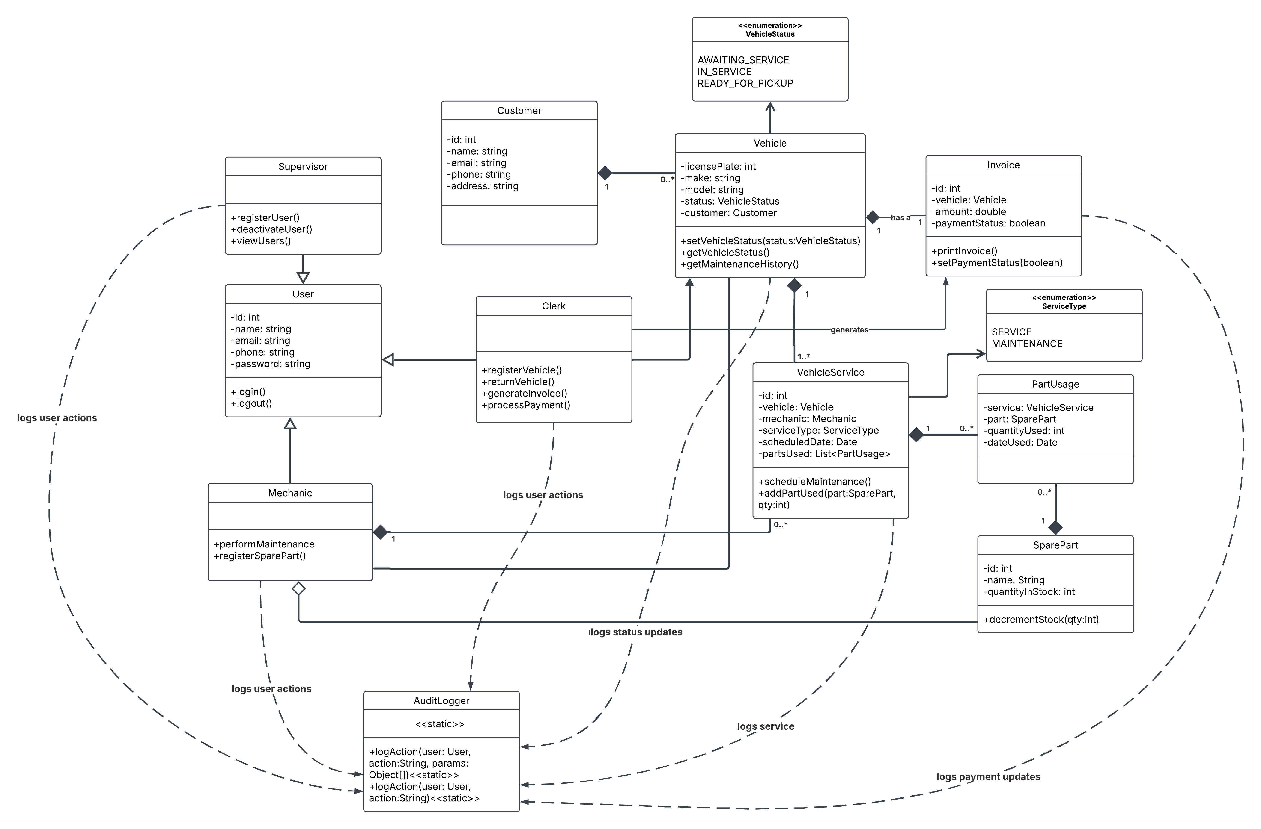

Decompose the application for security

User roles of the app
User Role | Description
Supervisor | Manages users and oversees operations.
Clerk | Registers/returns vehicle, processes payments, generates invoice
Mechanic | Performs maintenance, registers spare parts to inventory

Main processes and Data stores
Processes | Description
User Authentication | Login/Logout
User Management | Done by Supervisor
Vehicle Management | Vehicle registered by clerk, vehicle status managed by clerk and mechanic, vehicle service invoice generated by clerk, vehicle maintenance performed by mechanic, and vehicle returned by clerk
Spare parts Management | Registered by mechanic, used by mechanic, and usage tracked by system
Payment Processing | Processed by clerk, the application only records how the payment was made(cash or card), and for updating the payment status
Logging | Application/System logs various actions and changes

Data Stores | Description
User Database | User login credentials, profiles
Vehicle Database | Vehicle details, date of registration and status
Maintenance Database | Records of all maintenance done
Invoice Database | Stores the invoices of vehicles registered and their payment status
Payment Records | Payment History
Logging Database | Records of the actions performed in the app

Trust Level
User | Trust Level
Supervisor | High
Clerk | Medium
Mechanic | Medium

External Dependencies
External Dependency | Description
MySQL | Remote database server with MySQL running on them
JavaFX | An external Java library to make the application UI

Entry/Exit points
Entry/Exit Point | Trust Level
Login Interface | Low
Registration Interface | Medium
Payment Interface | Medium
Admin Panel | High
Maintenance Interface | Medium
Spare parts Interface | Medium

Assets
S.No. | Assets:
1 | User Credentials
2 | Vehicle Data
3 | Maintenance Records
4 | Spare Parts Inventory
5 | Payment Records
6 | Application Source Code

Data Flow Diagrams
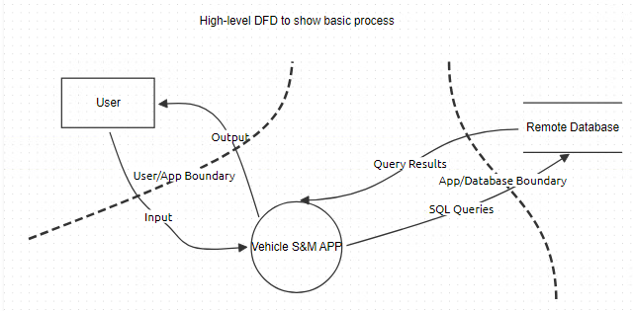

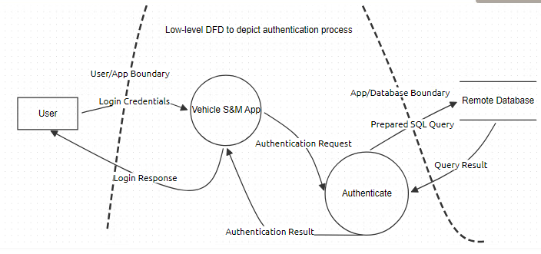
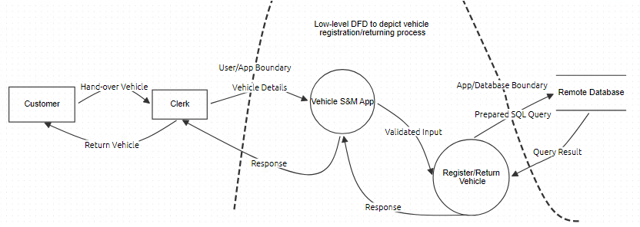

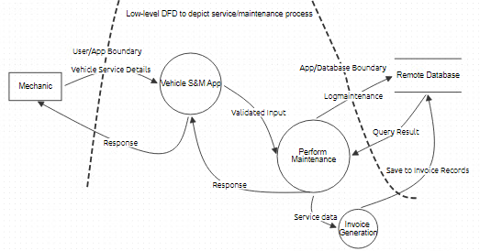

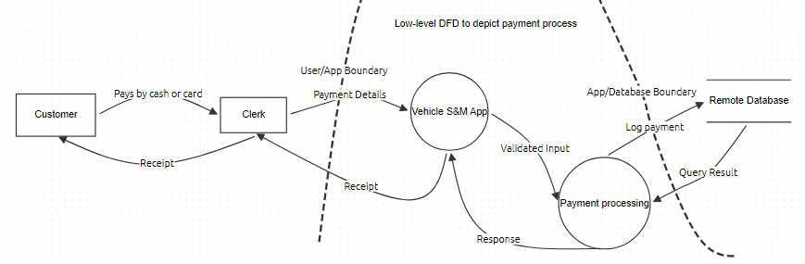
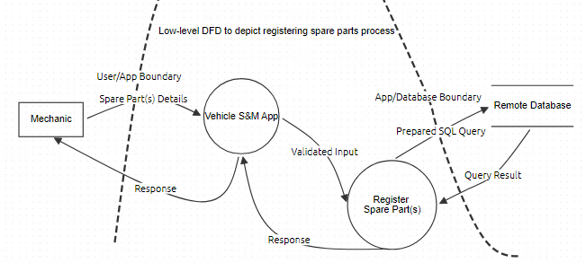

Determine and Rank Threats

STRIDE
Threat Category | Threat Description
Spoofing | Attacker impersonates a user and gains access to the system
Tampering | User manipulates service or payment records for malicious purposes
Repudiation | User denies making a change in the system
Information Disclosure | Attacker leaks user credentials/credit card info
Denial of Service | SQL injection or multiple login failures
Elevation of Privilege | Clerk/Mechanic user type gains supervisor privileges

DREAD
Threat | D | R | E | A | D | Total | Rating
Attacker impersonates a user and gains access to the system | 3 | 1 | 2 | 2 | 2 | 10 | Medium
User manipulates service or payment records for malicious purposes | 2 | 1 | 1 | 2 | 2 | 8 | Medium
User denies making a change in the system | 3 | 2 | 3 | 2 | 3 | 13 | High
Attacker leaks user credentials/credit card info | 2 | 2 | 2 | 3 | 2 | 11 | Medium
SQL injection or multiple login failures | 1 | 1 | 1 | 3 | 2 | 8 | Medium
Clerk/Mechanic user type gains supervisor privileges | 3 | 1 | 2 | 3 | 1 | 10 | Medium

Determine Countermeasures and Mitigation

Threat Description | Attacker impersonates a user and gains access to the system
Threat Target | User authentication process
Risk | Medium
Attack Techniques | Brute force, phishing, session hijacking
Countermeasures | Multi-factor authentication and session timeout

Threat Description | User manipulates service or payment records for malicious purposes
Threat Target | Maintenance Database, Invoice Database & Payment Records
Risk | Medium
Attack Techniques | SQL injection, parameter tampering
Countermeasures | Prepared statements, input validation and access control

Threat Description | User denies making a change in the system
Threat Target | Payment Status, Vehicle Status, Maintenance Database
Risk | High
Attack Techniques | Repudiation, log tampering
Countermeasures | Use logs protected with digital signatures to prevent tampering

Threat Description | Attacker leaks user credentials/credit card info
Threat Target | User credentials and payment information
Risk | Medium
Attack Techniques | Phishing, malware, data breach
Countermeasures | Encrypt data at rest and in transit, also use HTTPS

Threat Description | SQL injection or multiple login failures
Threat Target | Database and application availability
Risk | Medium
Attack Techniques | SQL injection, physical access to servers
Countermeasures | Prepared statements, input validation, restrict physical access

Threat Description | Clerk/Mechanic user type gains supervisor privileges
Threat Target | Full access of the application
Risk | Medium
Attack Techniques | Privilege escalation, broken access control, session hijacking
Countermeasures | Enforce role-based access control (RBAC) and validate user permissions on every request

